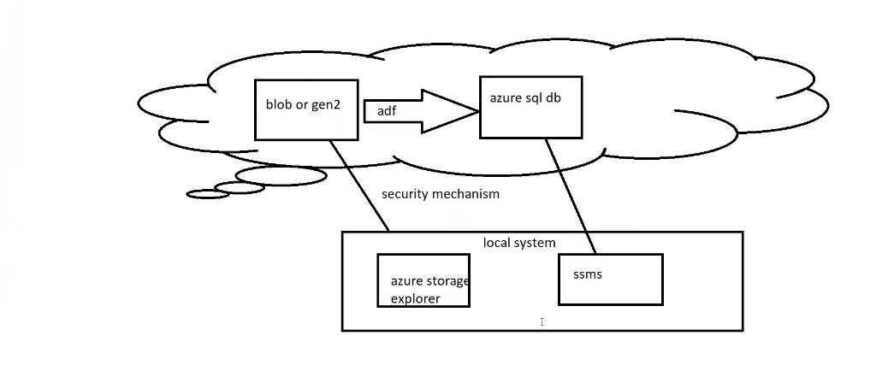
Create blob storage:
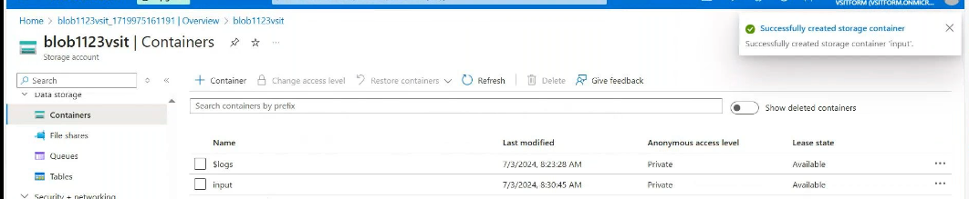
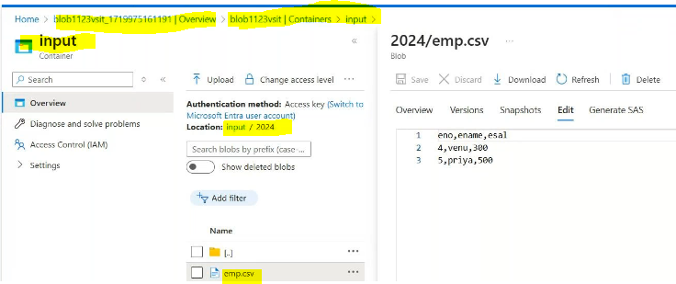
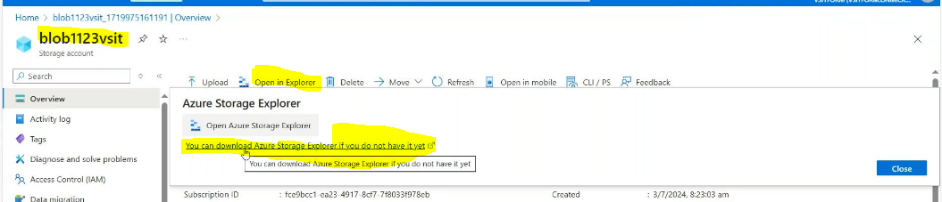
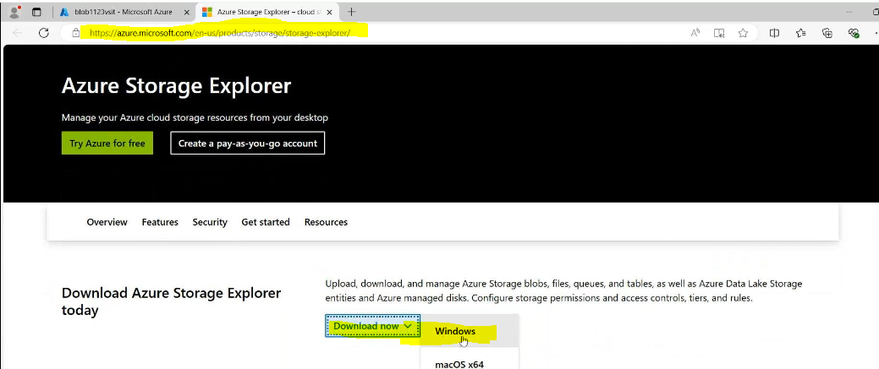
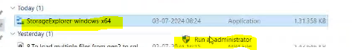
Accept the aggrement Install it
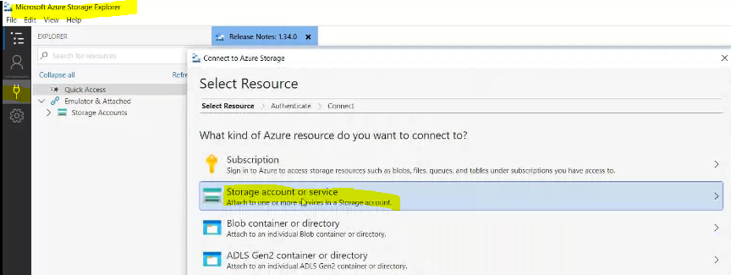
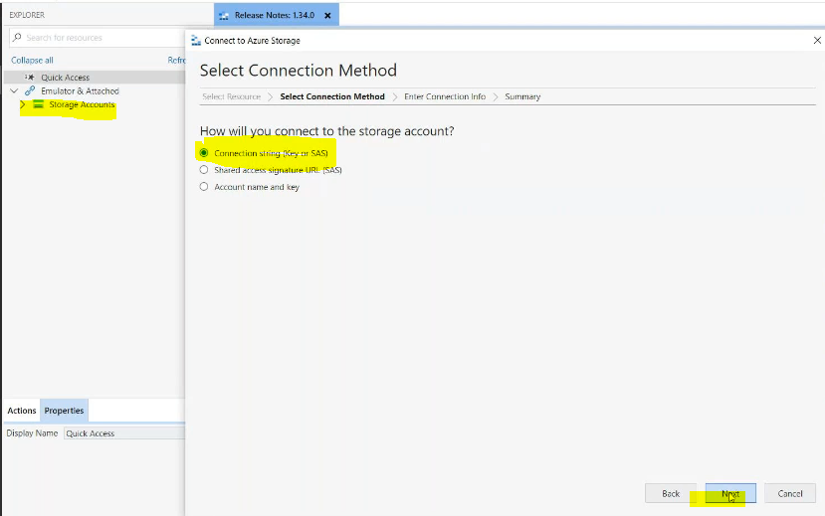
Go to blob acces key connection sting copy that one
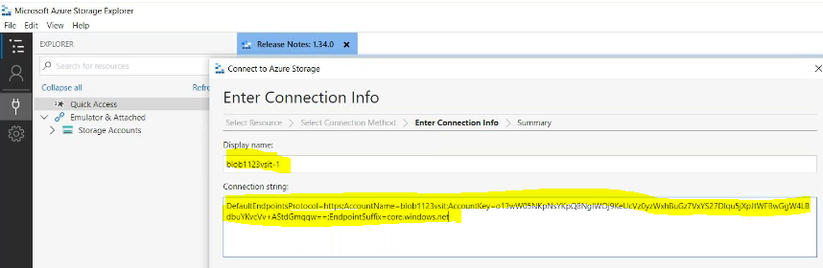
Connect it
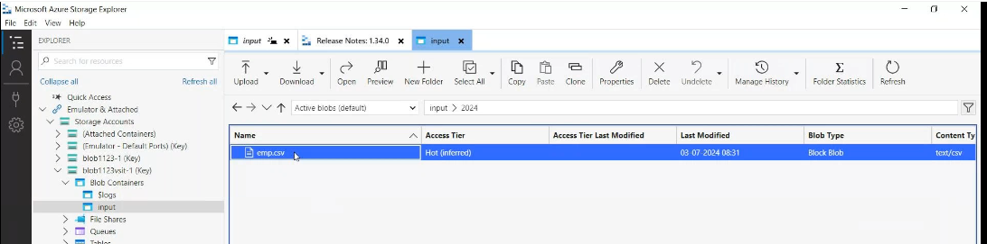
Here we need upload the files through our local system also and it will reflect in console also
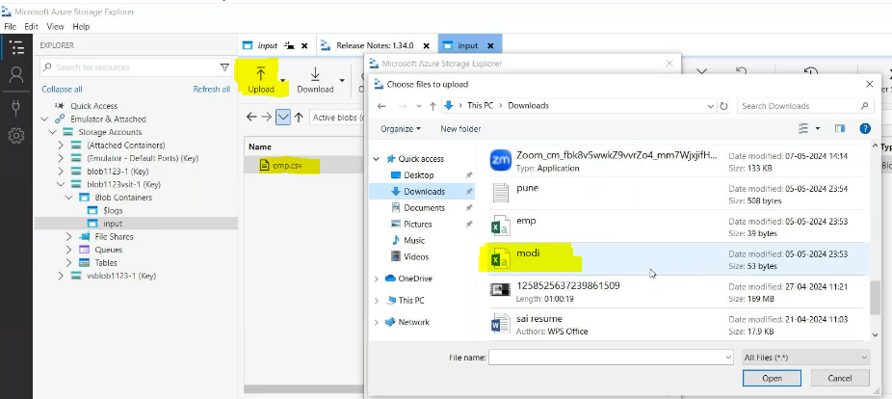
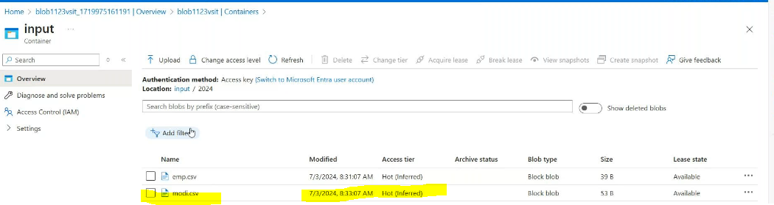
Then connect it by using shared access signature also
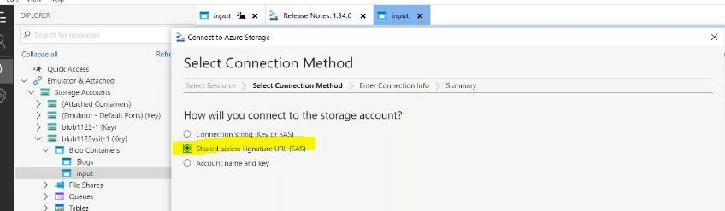
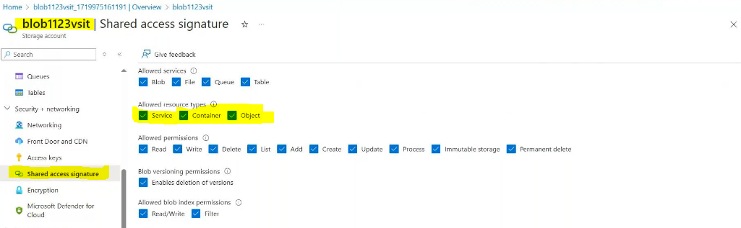

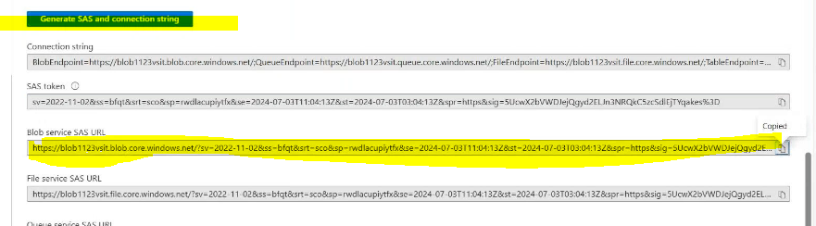
Then connect it .
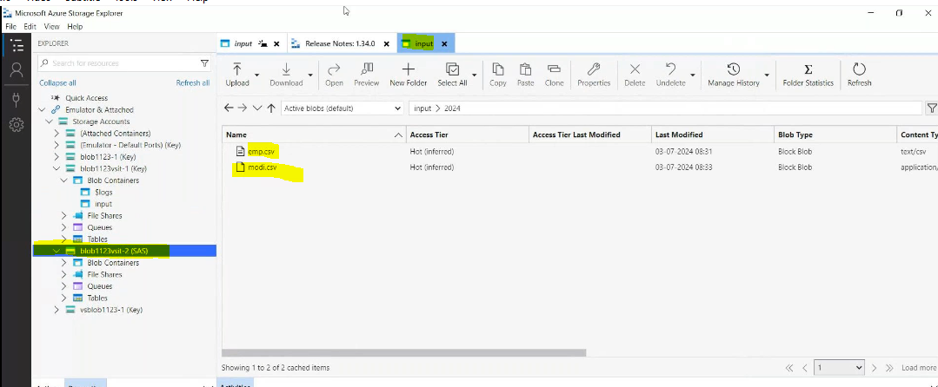
HOW TO LOGIN SQL SERVER THROUGH SSMS
Create a sql server in console
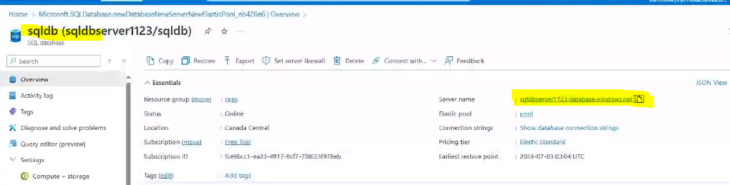
Open the ssms

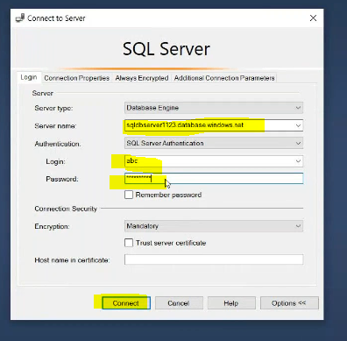
Create a ADF
Create linked services for source side and sink side
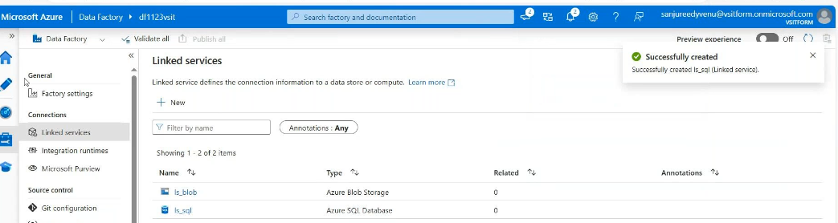
Create a datasets for source_side:
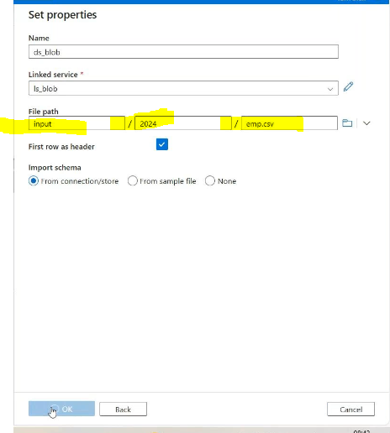

Create a datasets for sink_side:

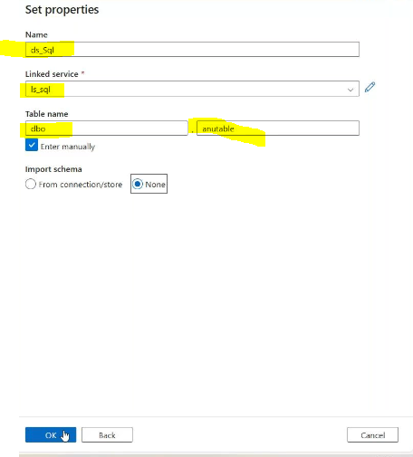
Create pipeline copy data activity
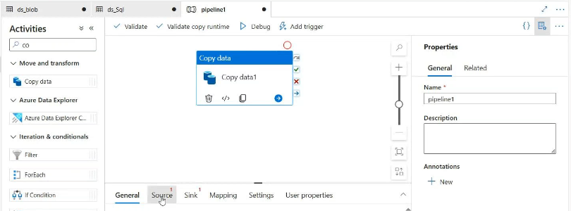
Source side:
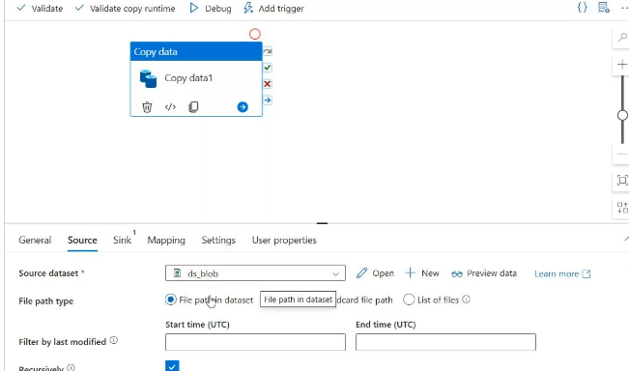
Sink_side:
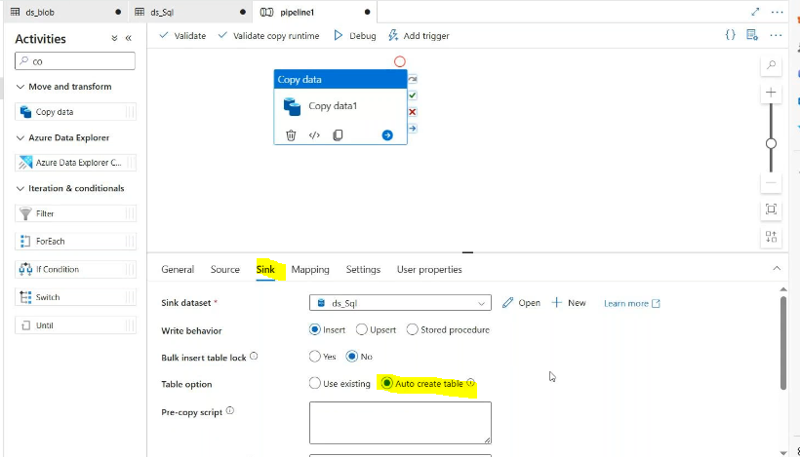

Validate & debug ->after success
Go to sql data base in consle
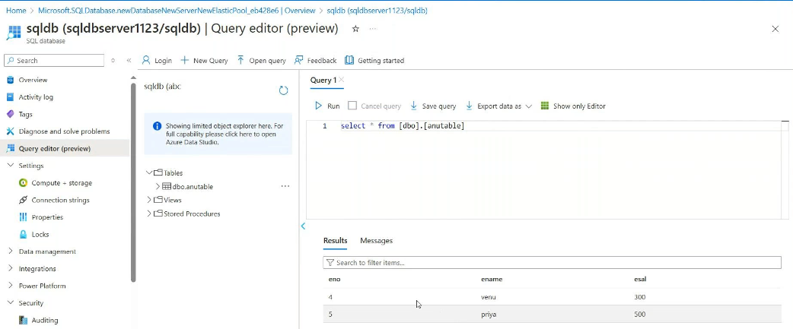
Check it in ssms also:
